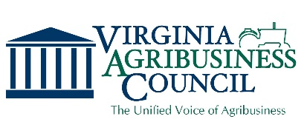
Sponsorship Agreement
Form

Please complete and email or mail to:
Virginia Agribusiness Council
9323 Midlothian Turnpike, Suite T
Richmond, VA 23235
Phone: (804)643-3555
vac@va-agribusiness.org
www.va-agribusiness.org

Sponsorship Opportunities:  Council Connections  Central VA at the Richmond Flying Squirrels (August 16, 2022)  ☐ Diamond Sponsor $750  ☐ Squirrel Sponsor $250  Sporting Clay Tournament (September 30, 2022)  ☐ Title Sponsor $1500  ☐ Ammo Sponsor $1000  ☐ Stand Sponsor with Team $550  ☐ Team Sponsor $450  ☐ Club Sponsor $500  ☐ Lunch Sponsor $300  ☐ Stand Sponsor $150  ☐ Contest Sponsor $150  ☐ In-kind Sponsor (donations for player bags)  ___________________________________  Please describe item(s) | Please Type or Print Clearly  ___________________________________________________ Contact ___________________________________________________ Company ___________________________________________________ Address ___________________________________________________  City, State, Zip Code ___________________________________________________  Phone & Fax ___________________________________________________  Email  ___________________________________________________  Website  Method of Payment  ☐ Check Enclosed  ☐ Prefer to Pay Online with Credit Card (2.5% service fee applied)  ________________________________________________________  Signature

